**CLAP SWITCH USING ARDUINO UNO**

**An Undergraduate Project**

**Presented to the**

**COLLEGE OF TECHNOLOGY AND ENGINEERING**

**CEBU TECHNOLOGICAL UNIVERSITY**

**San Francisco Campus**

**San Francisco Cebu**

**In Partial Fulfilment**

**Of the Requirements for the course of**

**Bachelor of Industrial Technology Major in**

**Computer Technology**

**CT 329- Embedded Systems**

**CUBOS, MERYGEN**

**COLARTE, JELLY-ANN G.**

**INTAN, CRISLYN E.**

**MAURILLO, NORBERT M.**

**CATALAN, LEOGEN**

**MAY 2023**

**Guideline for the documentation of our final project:**

**Introduction:**

• Project Context

• Purpose and Description of the project

• Objectives of the Project

**Technical Background:**• Technicality of the project

• Details of the technologies to be used

• How the project will work • Circuit diagram of the project

**Methodology:**

• Data and Process Modeling

• Context Diagram

• Data Flow Diagram

• System Flowchart

• Program Flowchart

• System Architecture

• Network Topology

• Parts and equipment needed

• Software specification

• Installation process

• Building the circuits

**Testing:** • System testing • Users guide

**CODE:**

**#include <Arduino.h>**

**#define mic_analog_read_trigger 65**

**#define mic_pin A0**

**#define out 8**

**float mic_analog = 0;**

**bool is_trigger = 1;**

**void setup()**

**{**

**Serial.begin(9600);**

**Serial.println("READY");**

**pinMode(mic_pin, INPUT);**

**pinMode(out, OUTPUT);**

**digitalWrite(out, HIGH);**

**}**

**void loop()**

**{**

**mic_analog = analogRead(mic_pin);**

**if (mic_analog >= mic_analog_read_trigger)**

**{**

**Serial.println("Mic trigger");**

**digitalWrite(out, is_trigger);**

**delay(500);**

**is_trigger = !is_trigger;**

**}**

**}**

**CHAPTER 1**

**Introduction:**

In this project we are going to make a clap switch using Arduino Uno. The clap switch is used in a wide range of electronic projects, to control devices by clapping or making a specific sound. The clap switch consists of a Sound Sensor module connected to a microcontroller, or to an Arduino board. And through a software code, the audio signal can be converted into a key to turn on and off electronic devices or electronic circuits. Clap switch circuit can detect noises to turn the bulb on. A clap switch circuit can be used in homes and businesses to turn on things such as: lights, TVs, or whatever it is set up to the clap switch. In many cases you can snap your fingers, clap your hands, or even speak to it.

**Technicality of the Project :**This is a project on CLAP SWITCH which can switch on/off any electrical circuit by the sound of the clap. A clap switch is an electronic device that works based on clapping action, it converts sound energy into electrical pulses and proved these electrical pulses as input to the control circuit for controlling the light appliances. The main advantage of this technology is that it is very much helpful for a mobility-impaired person.**Details of the technologies to be used :** The Clap switch using Arduino Uno is integrated with some hardware components such as Arduino Uno, Sound Sensor, Jumper Wires, 5V Relay Module, Arduino data cable with OTG, Bulb, Plug Wires( Male, Female) etc.

* **Arduino UNO** is a low-cost, flexible, and easy-to-use programmable open-source microcontroller board that can be integrated into a variety of electronic projects. This board can be interfaced with other Arduino boards, Arduino shields, Raspberry Pi boards and can control relays, LEDs, servos, and motors as an output.
* The **sound sensor** is a module that monitors and detects the sound signals like voice, claps, snaps, knocks, etc. It is also known as an acoustic sensor or sound detector. Used in various applications such as security systems, monitoring systems, radios, telephones, mobile phones, computers, home automation systems, consumer electronic appliances, etc
* A **5V relay module** is a single or multi-channel relay module that works with a low-level trigger voltage of 5V DC. The input voltage can be from any microcontroller or logic chip that outputs a digital signal.
* **Arduino data cable with OTG.** This cable is used to interface any of the Arduino board with your computer, you can also connect your USB printer, scanner, and more to your computer. These cables Transmits data at high speeds with the error-free, high-performance transmission.
* **Jumper wires** typically come in three versions: male-to-male, male-to-female and female-to-female. The difference between each is in the end point of the wire. Male ends have a pin protruding and can plug into things, while female ends do not and are used to plug things into.
* A **light-emitting diode** is a semiconductor device that emits light when current flows through it. Electrons in the semiconductor recombine with electron holes, releasing energy in the form of photons. The color of the light is determined by the energy required for electrons to cross the band gap of the semiconductor.
* **Bulb-** An electronic bulb is a small and simple light source that uses a wire filament to glow on the application of electricity. The structure of incandescent light bulbs is shown in the figure below. The light bulb consists of three key parts. The filament. The glass bulb.

**How the project will wor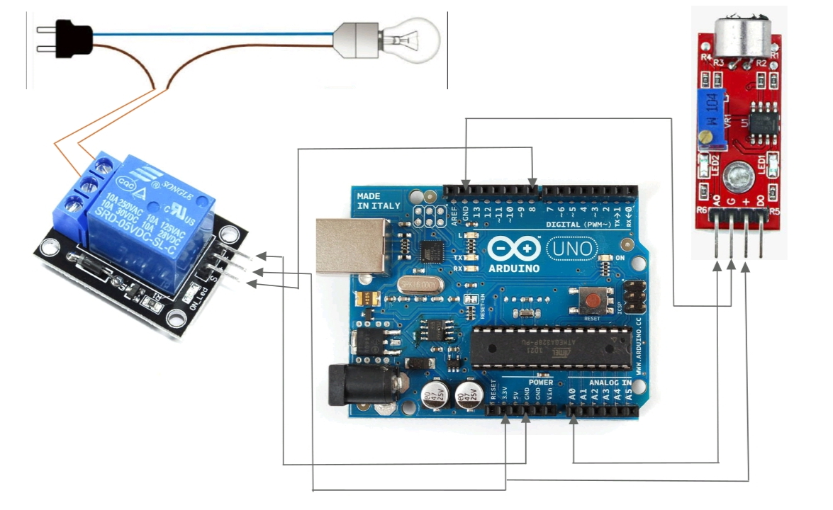k :**The project will work using by Arduino Uno, Sound Sensor, Jumper Wires, 5Vs relay, Arduino data cable with OTG, Adapter, LED, all the equipments needed to the project and Also the code that we used. The most important project will work if the group members will co-operate each one of us, planning the work of the project.**Circuit diagram of the project :**

The microphone sound sensor, as the name says, detects sound. It gives a measurement of how loud a sound is.There are a wide variety of these sensors. In the figure below you can see the most common used with the Arduino.

Arduino is a microcontroller based prototyping board that runs on small DC power. A Relay is a device that helps microcontrollers (or microcontroller based boards) like Arduino to switch on or off different household appliances like motors, lights, water heaters, television and fans etc.

Today, Arduino is being used for a wide range of applications like controlling LEDs, monitoring temperature, logging data and turning on motors etc. Another important task that can be accomplished by the Arduino is controlling a 5V Relay to operate high voltage AC appliances and devices.

Arduino UNO can be programmed to control a simple 5V relay example switch it on or off on the event by clapping. In this project, we will see a simple circuit where an Arduino UNO will control a 5V relay, which in turn will a lamb.

Let us see the circuit diagram for the project. Even though we have used a 5V Relay Module, the connections in this circuit diagram will be describe the complete setup.

**CHAPTER 2**

**METHODOLOGY**

**Data and Process Modeling**

**Context Diagram :**

- Context diagram shows the main component: Clap switch, The Electric Condenser Mic.

- The Clap switch is the main component of the system and it is used for the house and so you don't need to go to the switch of your light so you just clap to turn ON and OFF your light. We a sound sensor to detect the sound to turn the light on and off. then also it is connected to the internet to send data to the cloud server and for the clap switch to work.

- The circuit is the Electric Condenser Mic, which has been used as a sound sensor. Condenser Mic basically converts sound energy into electrical energy, that in turns used to trigger 555 timer IC, through a Transistor. And triggering of 555 ic works as a Clock pulse for D-type flip-flop and would turn ON the LED, which will remain ON until the next clock pulse means until the next Clap/sound. So this is the Clap Switch which will turn ON with first Clap and turn OFF with the second Clap. If we remove the D-type Flip flop from the circuit, the LED will be turned OFF automatically.

**Data Flow Diagram :**

- A "Clap On Clap Off" switch is an interesting concept that could be used in home automation. It works as a switch which makes devices On and Off by making a clap sound. Although its name is “Clap switch”, but it can be turned ON by any sound of abo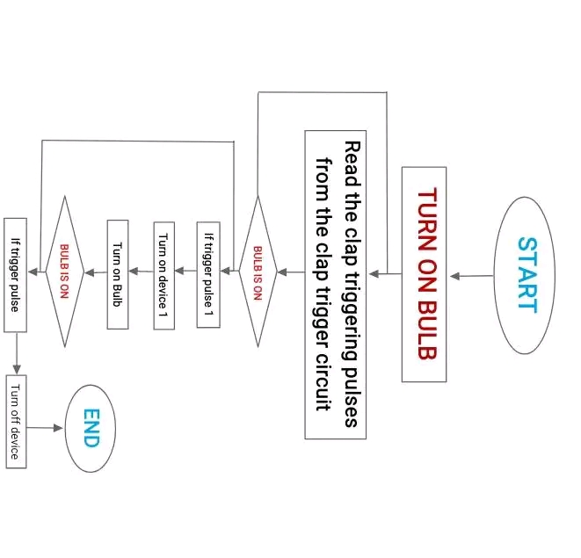ut same pitch of Clap sound.

**System Flowchart :**

**Parts and equipment needed :**

**• Arduino Uno**

**• 5v Relay**

**• Sound Sensor**

**• USB cable with OTG**

**• Jumper Wires**

**• Bulb**

**• IC 555 Trigger**

**• Plug Wire**

**Installation process :**

**Step 1 :** We gathered all the materials like Arduino Uno, Sound Sensor, 5V Relay Module, Jumper Wires, USB cable with OTG, 2 Wires (Positive and Negative), Plug Wire and Bulb.

**Step 2 :** Put a jumper wire on the Arduino Uno and connect to sound sensor.

**Step 3 :** From Arduino connect to relay.

**Step 4 :** From relay connect to the bulb and plug wire

**Step 5 :** USB cable direct to mobile phone or smartphone.

**Step 6 :** Upload a code.

**Step 7 :** Plug in to the outlet.

**Step 8 :** Start working.

**Testing :**

• User Guide

- Clap switch using Arduino Uno

The Clap switch using Arduino Uno project is very innovative you can use it everywhere like a house, theatre and etc. This user guide will provide step-by-step instructions on how to set up and how to make a code to work it on.

**Components Needed :**

• Sound sensor • 2 Wires (Positive and Negative)

• Arduino UNO • Cartoon (To build a small house)

• 5V Relay Module • Bulb

• Jumper wires (Male, Female) • Scissor

• USB cable with OTG • Plug Wire

• Cutter • Stick Glue

**Step 1 : Hardware set-up**

**1.** Connect the Arduino board to your computer through USB cable.

2. Place the Arduino Uno to relay and sound sensor.

3. Connect the GND to relay

4. Connect the 3.3V to relay

5. Connect the digital pin 8 to relay

6. Connect 3.3V to Sound Sensor

7. Connect A0 to sound sensor

8. Connect GND to sound sensor

9. Make sure all the connection are properly connected.

**Step 2. Software Setup**

**1.** Download and install the Arduino IDE.

2. Open the Arduino IDE.

**Select the appropriate board and port from the "tools" menu.**

**3.** Open a new sketch and input the code.

4. Verify the code for any errors by clicking the checkmark icon.

5. Upload the code to the Arduino board by clicking the right arrow icon.

**Step 3. Assembling the Clap Switch**

1. Place the Arduino board on the floor inside a house.

2. Attach the relay on the floor beside the Arduino Uno.

3. The sound sensor must be put up the rooftop of a house so that it can detect the clap sound.

4. The jumper wire must be stick on the tape.

5. Attached the bulb on top and put some stick Glue in the wire.

6. Insert the USB cable to the Arduino Uno and connect to the smartphone.

**Step 4. Testing and Usage**

**1.** Power up the Arduino board using a power supply.

2. Try using it.

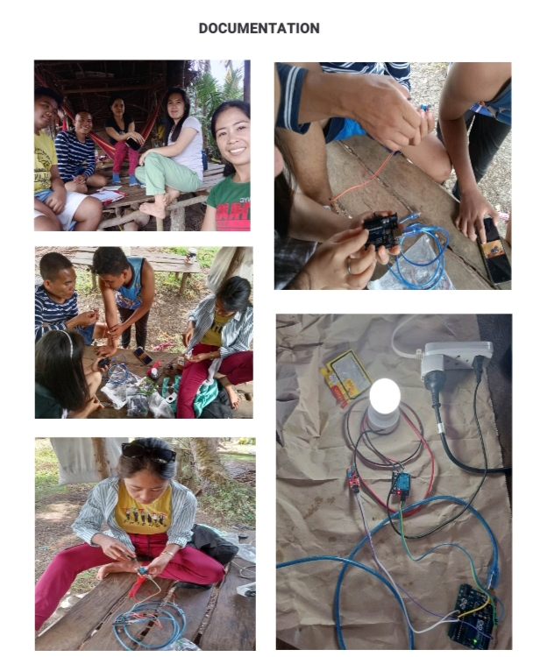**DOCUMENTATION**

